**“Quotetopia”**“A place for a moment of clarity in your life”

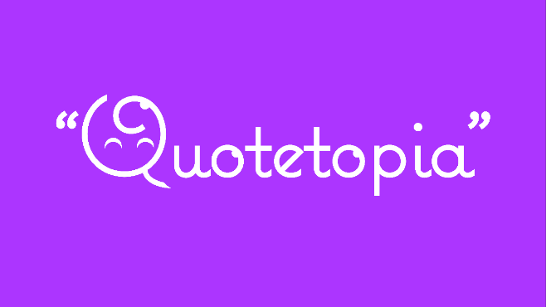 

 

 

**Abstract**

“Quotetopia” is a free app that allows a user to select a category(s) of interest (ex. weight loss, inspirational, author, actor, motivational, etc.) and generates a quote that relates to that topic. On the background of the quote, there will be a picture that relates to that category. The app will allow the user to download the picture and have it as a wallpaper for them to use on their phone.

**1.    Background**

Quotes can be very inspirational and motivational to one. Quotes have a property that gives someone a moment of clarity to achieve what they want to do. Some just need to read the right words to lift their days. “Quotetopia” was created to give someone the ability to find what they need to read or see for the day to tackle any challenges or obstacles they are facing in their lives. Creating an app like this makes it easy and simple for someone to browse through a list of topics that may relate to their needs. Reading a quote can literally change a person’s mood for the day.

**2.    Motivation and Contribution**

As a student, it can be hard to go through the day. Sometimes, a friend will give some words of motivation. But there’s other days that go by without some inspiration or drive to keep going. Quotetopia’s purpose is to help relieve stress, anxiety, and provide drive someone’s day. It can also be used to read some quotes for fun.

**3.    Goals**

The goal is to have this app done by the end of the semester and hopefully launch this app to the Google Play Store for free with targeted ads. This app’s purpose is to make sure that these quotes grant no distractions or hardships from vendors or companies that do not relate to their interests. Quotes are supposed to be a way to relieve some stress or provide clarity in life. However, with targeted ads based on the user’s selection of category, the app can provide the user with products that may benefit their goals by using ads related to topic. If the user selects the “Fitness” category, they’ll see an ad that is about exercise gloves or a fitness ball. At the end, this app is meant to provide the user with the ability to start their day with inspiration

**4.    Interface**

The user interface is very simple and easy to navigate. Once the user starts the app, they will be prompted with a list of different topics to pick from. Fitness, Motivational, Inspirational, Entrepreneurs, Authors, Books, and more will be listed to pick from. An example is below:

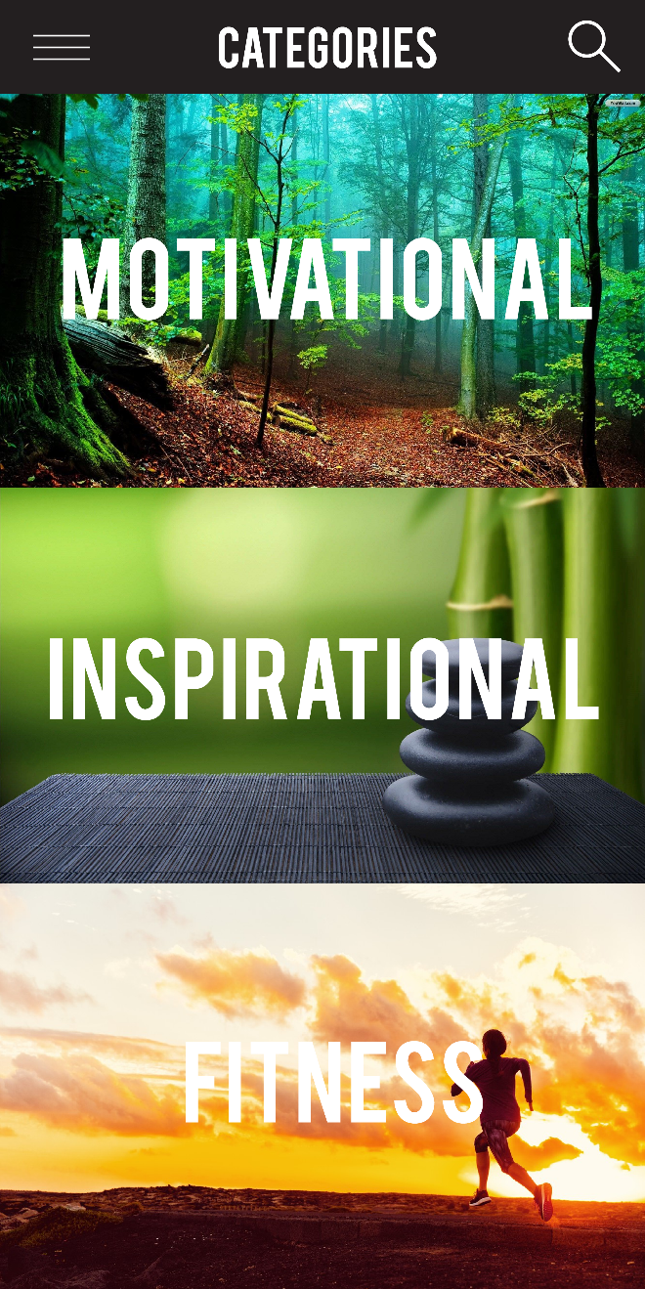 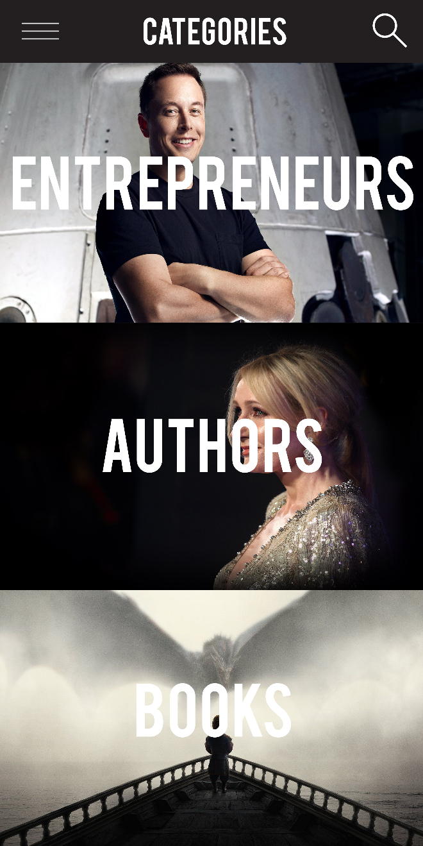

When selecting a topic, the user will be prompted with a quote that relates to the topic. The quotes will come from a database and/or API that generates a random quote from that topic. Along with that, the quote will also have a wallpaper in the background that will shuffle every so often with different pictures that relate to the topic. An example is below:

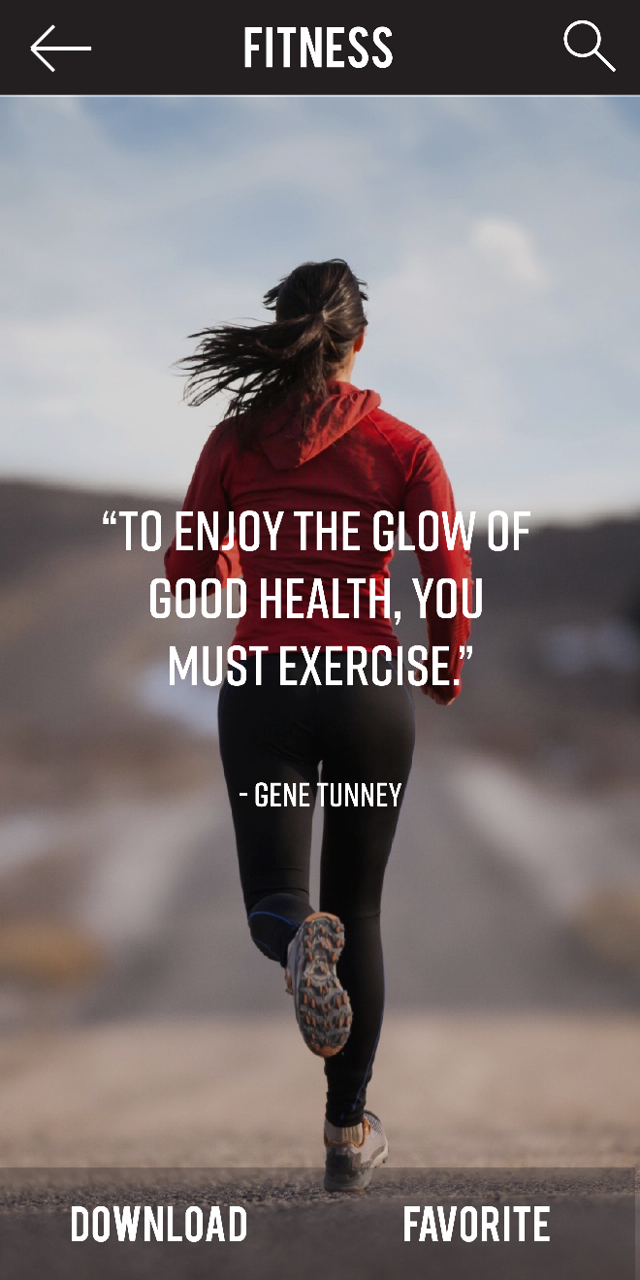 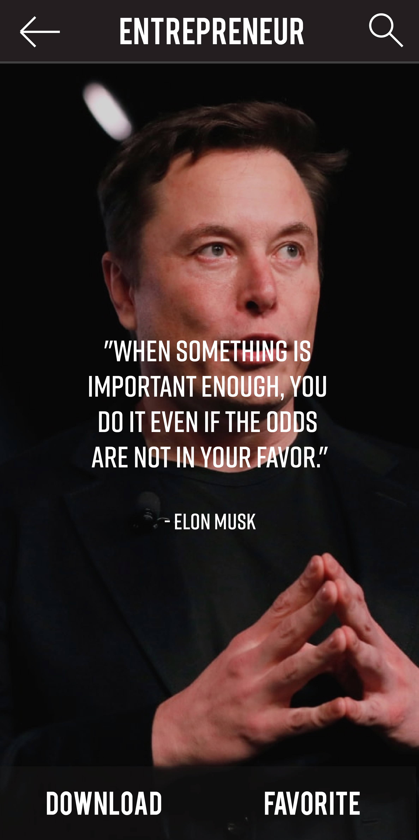

**5.    Functions**

The app will have some important functions to the user that will be implemented to the app. The following functions will be a part of the app:

1. Favorites: Allows the user to favorite their quotes to their app so they can always look back to them.
2. Download: The users can download the pictures that the quote comes in.
3. Search: The app can search through keywords of the database and display quotes that relate to their search.
4. Menu/Back Button: The user can go back to the categories section where a list of topics is available to scroll through. At the menu, the user will also be able to see the downloads and favorite quotes they saved. They are also able to report a picture or quote that was offensive or inappropriate.

**6.    Challenges**

Some of the challenges for this project are getting the quotes and searching through them in a database. Once the user selects a topic, the app must able to go through every quote that relates to the topic. Organizing that database will take time. If the user searches for a keyword, the database must be able to spit out a quote that relates to the keywords the user inputted.

Another challenge is pictures in the background of the quote being displayed. Once the user selects a topic, for every quote, the app must be able to randomly select a picture from Google or a database and randomly place it in the background of the app.

Finally, having the app be able to download the quote with the picture in the back of it. This is so that the user can download the quote and save it on their phone’s as a wallpaper. These challenges can be easy to tackle; however, the database part of the app will probably be the hardest to accomplish.

**7.    Framework/Architecture**

The framework used for this project will be using Android Studio and Java to implement all the coding and app development for this project. This project will be using APIs such as Google Image Search to generate a picture in the background. The pictures will need to come from the internet, so the app will need to have internet to use its full potential. If the app does not have internet, then the app will use its default picture images to provide a background for the quotes. The quotes will use a database created using a .txt files to monitor and keep track of the quotes and author of the quote; however, if possible, some of the quotes will come from an API in the near future.

**8.    Timeline**

1. Proposal Submitted **– 9/30**
2. Develop app’s menus **– 10/1 - 10/6**
3. Develop up to 6 permanent categories **– 10/1 - 10/6**
4. ***Begin creating database for the 6 categories that randomly outputs a quote depending on the topic **– 10/7**
5. Implement random picture in the background of each quote on the app **– 10/7-10/17**
6. ***Finish creating test database with quotes from the 6 topics **– 10/20**
7. Test random quote output (MUST DISPLAY BOTH PICTURE AND QUOTE) **– 10/25**
8. Halloween Break **– 10/26-10/31**
9. Create Download function **- 11/3**
10. Create Favorite function **- 11/3**
11. Create Search function **- 11/3**
12. Prepare presentation **– 11/3 – 11/15**
13. Finalize project **- 11/15**